**Delapre Park Lake Microplastic Survey Report**

**By Lema Ashrafe**

Executive summary-

This project investigates microplastic contamination in sediment from Delapré Park lake, Northampton. Using a low-cost density separation technique and basic filtration, sediment samples were collected and processed to isolate microplastic particles. This analysis revealed synthetic fibres and fragments which likely originated from local anthropogenic sources such as litter. QGIS was used for geospatial mapping and showed spatial variation in particle abundance. This study demonstrates accessible environmental monitoring techniques which are suitable for student-led field research.

Introduction-

Microplastic pollution has become a resistant environmental issue. It impacts ecosystems, human health and wildlife. Microplastics are defined as plastic particles smaller than 5mm ((Frias and Nash,2019) and they are present in a variety of aquatic environments. This includes rivers and wetlands. . Accumulation of microplastics within sediments could be a major issue as it can alter ecosystem functions and disrupt species (Nageen Bostan et al., 2023).

Delapré Park is a public park and heritage site located in Northampton, UK(west northamptonshire council,2023) . Its central lake is surrounded by a mix of recreational green space, footpaths, and tree cover. Due to its urban location and potential exposure to anthropogenic runoff, the lake represents an ideal site for investigating local microplastic deposition.

This project aimed to conduct a microplastic presence survey in the Delapré Park lake using a simple floatation and filtration method to isolate and observe plastic particles from sediment samples. The objective was to demonstrate proof-of-concept microplastic sampling and analysis in a local setting using low-cost, replicable methods, while also applying GIS mapping for spatial representation.

Methods-

Sample Collection Three samples (DP1, DP2, DP3) were collected from different zones of the Delapré Park lake shoreline: the north edge, the central bank, and the southwest inlet. At each location, approximately 60 g of surface sediment (top 2–3 cm) was scooped into a 250 mL sample jar using a clean plastic trowel. Gloves were worn to avoid contamination. Environmental conditions, site notes, and georeferenced photos were recorded at each location using a smartphone. Coordinates were captured using the OS Compass mobile application.

Preparation of Salt Solution A saturated salt solution was prepared by dissolving 1 kg of table salt (NaCl) in 2 L of warm tap water in a plastic mixing container. The solution was stirred until undissolved salt settled at the bottom, indicating saturation.

Density Separation and Filtration Each 60 g sediment sample was combined with 300 mL of the saturated salt solution in a separate 500 mL plastic tub. The mixtures were stirred gently for 2 minutes to break up clumps and left to settle undisturbed for 1 hour. Supernatants were then decanted carefully through funnels lined with qualitative filter paper (15–20 µm pore size). The filters were left to air-dry on a clean, dark surface for later inspection. A 10× handheld magnifying lens was used to examine dried filters for plastic particles.

Results-

Image 1:

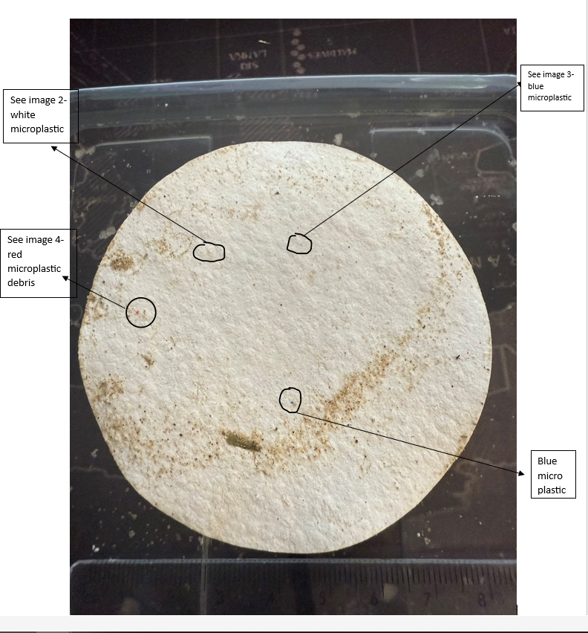

Image 2:

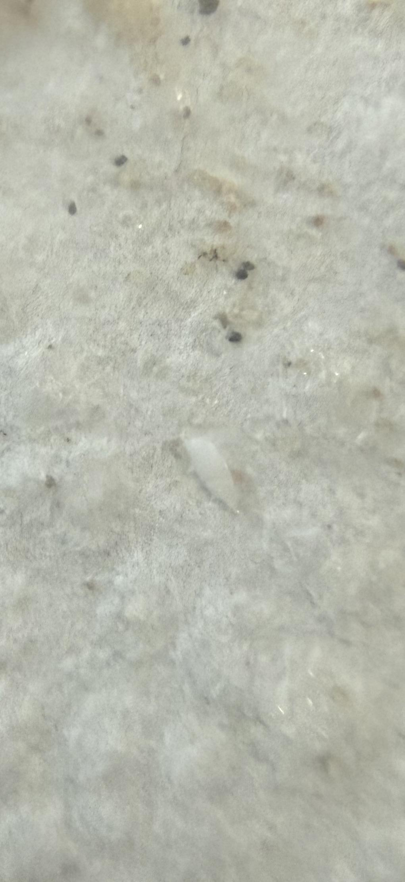

White PET fragment (~1.2 mm) from DP1 filter, shown under 10× magnification.

Image 3:

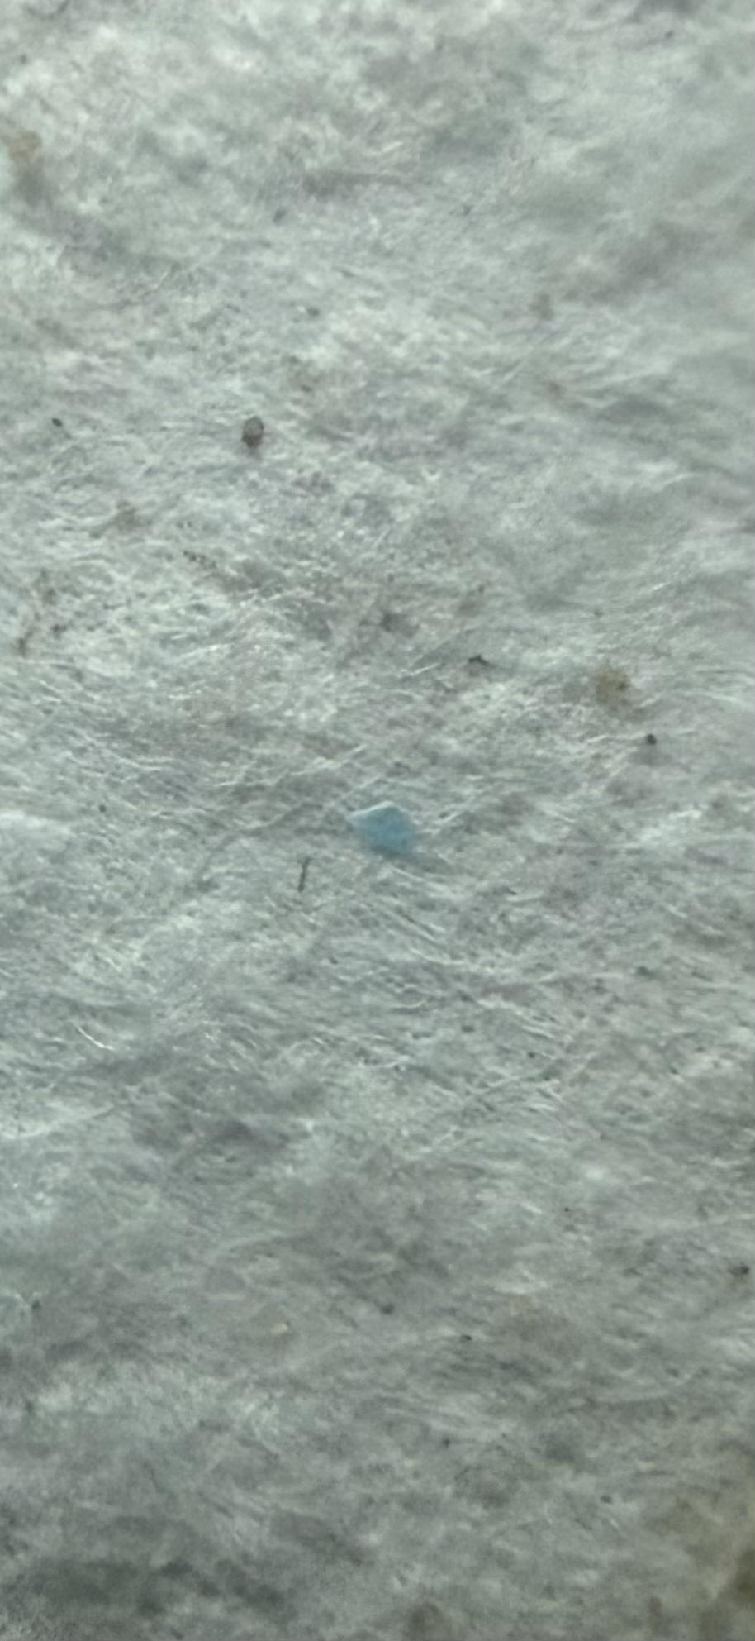

Blue synthetic fibre (~1.1 mm) from DP1 filter, captured at 10× magnification

Image 4:

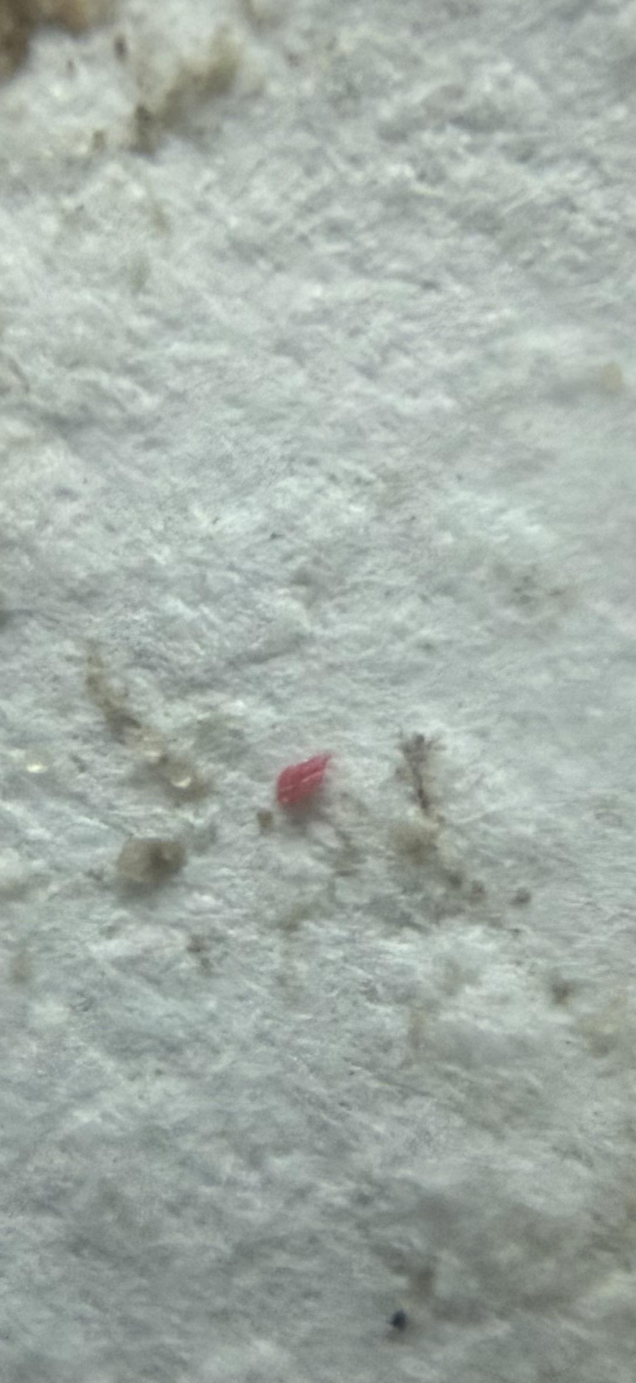

Red polypropylene fragment (~1.0 mm) from DP1 filter, visible under 10× handheld magnifier

Image 5:

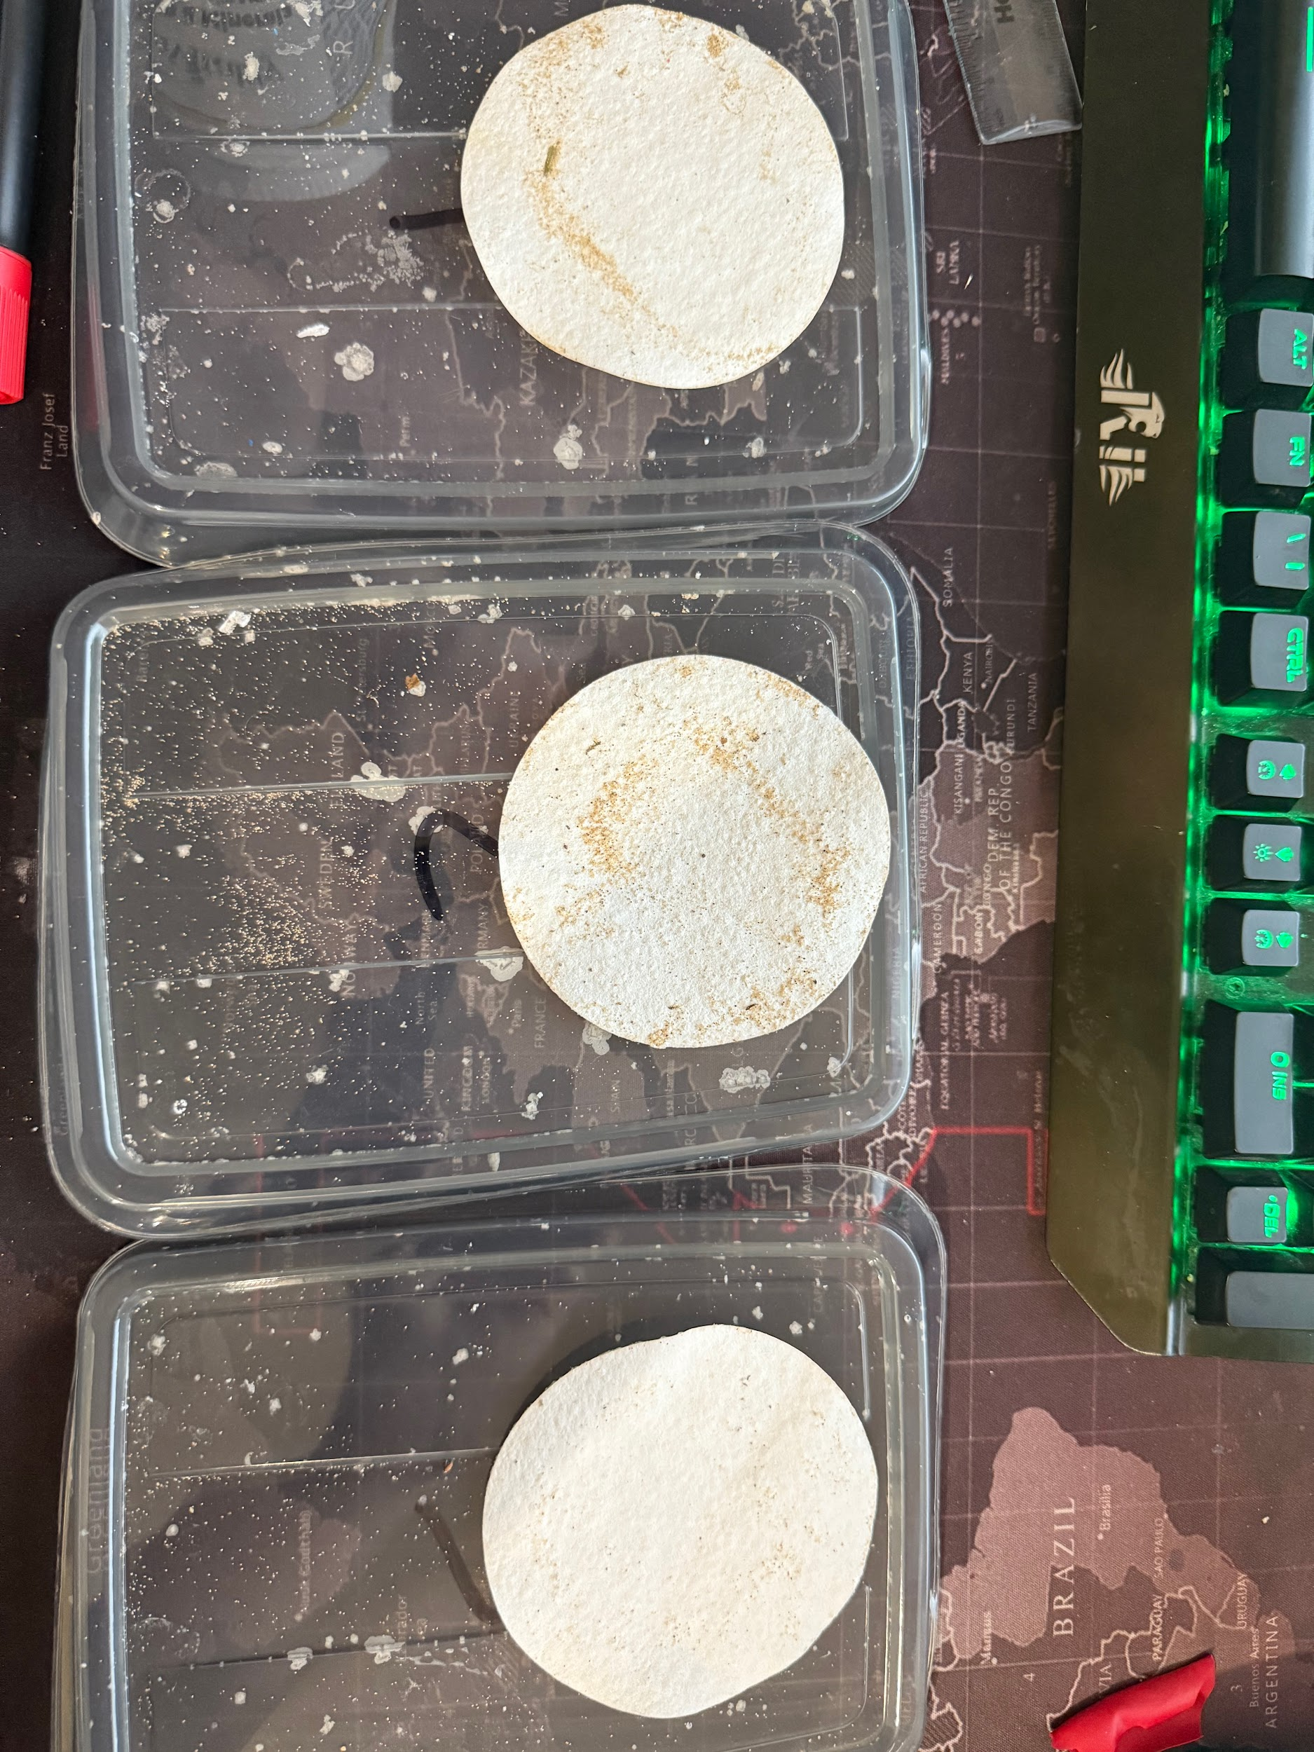

This image shows a side by side comparison of the filter papers from DP1, DP2 and DP3.

The table below summarizes microplastic counts and characteristics for each Delapré Park lake sample (DP1–DP3). All values are based on processing 60 g of sediment with a NaCl density separation, followed by filtration (15–20 µm) and 10× magnifier inspection.

Table 1:

| Sample | Sediment Mass (g) | Total Particles | Particles per g | Fibres | Fragments | Average Size (mm) | Common Colours |
| --- | --- | --- | --- | --- | --- | --- | --- |
| DP1 | 60 | 4 | 0.067 | 3 | 1 | 1.2 | blue, red, white |
| DP2 | 60 | 2 | 0.033 | 1 | 1 | 0.9 | white, black |
| DP3 | 60 | 0 | 0.000 | 0 | 0 | — | — |

DP1 (nearest urban footpaths) contained four microplastics: three fibres (≈ 1.0–1.4 mm) and one fragment (≈ 1.2 mm). Colours observed were blue, red, and white.

DP2 (intermediate location) contained two microplastics: one fibre (≈ 0.8 mm) and one fragment (≈ 1.0 mm). Colours observed were white and black.

DP3 (most rural inlet) contained no detectable microplastics.

Figure 1:

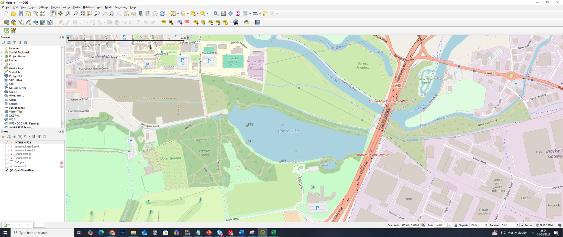

Figure 1: Sampling locations (DP1, DP2, DP3) plotted in QGIS (QGIS Development Team, 2023).

Sampling locations (DP1, DP2, and DP3) were plotted in QGIS (QGIS Development Team, 2023), and samples were collected on 23 May 2025 under 22 °C weather conditions.

Figure 2:

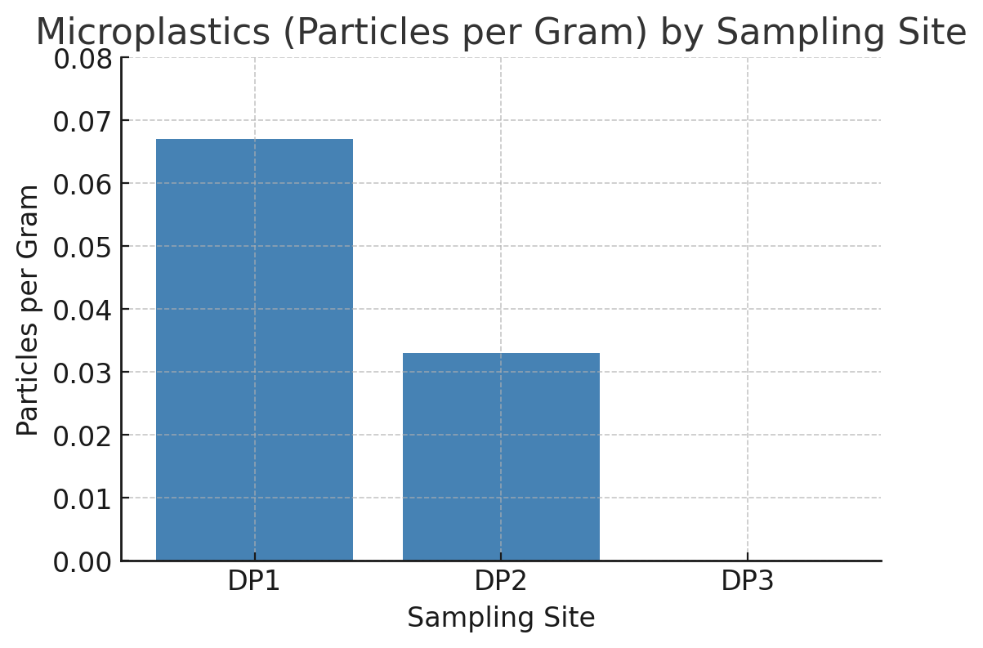

The bar chart displays “Particles per Gram” for DP1, DP2, and DP3, illustrating a clear decreasing trend:

* DP1 shows the highest bar (0.067 particles/g),
* DP2 is lower (0.033 particles/g),
* DP3 sits at zero (0.000 particles/g).

This pattern aligns with our expectation that microplastic abundance would decline moving away from urban influence. DP1—nearest to footpaths and recreational areas—had the greatest microplastic load. DP2, located farther from pedestrian traffic, had about half as many particles per gram. Finally, DP3, in the most secluded inlet, had no detectable microplastics.

Thus, the bar chart confirms our hypothesis: closer proximity to likely plastic sources corresponds to higher microplastic concentrations in pond sediments.

### Descriptive Trends

1. Particles per Gram:  
   * DP1: 4 ÷ 60 = 0.067
   * DP2: 2 ÷ 60 = 0.033
   * DP3: 0 ÷ 60 = 0.000
2. Type Distribution:  
   * DP1: 75 % fibres, 25 % fragments
   * DP2: 50 % fibres, 50 % fragments
   * DP3: 0 % (no particles)
3. Size Trends:  
   * DP1 average ≈ 1.2 mm
   * DP2 average ≈ 0.9 mm
   * DP3: n/a
4. Colour Indicators:  
   * Blue, red, white at DP1 imply textile and packaging sources.
   * White, black at DP2 suggest degraded fragments and textile input.
   * DP3 shows no detectable contamination at this filter threshold.

Potential Sources of Microplastics-

The Delapré Park lake is bordered by footpaths, recreational lawns, and forested areas, suggesting multiple potential sources of plastic input. These may include litter runoff, degraded packaging, synthetic textile fibres from clothing, and atmospheric deposition. The proximity of pedestrian areas and general public use of the park makes it likely that recreational activity contributes to the accumulation of microplastics in the sediment.

The dominant microplastic types observed—fibres and small irregular fragments—are often associated with urban environments. fibres are most likely derived from synthetic textiles, especially clothing washed in domestic laundry and dispersed through airborne or wastewater pathways. Fragments may originate from the degradation of plastic packaging, disposable food containers, or littered materials that break down under UV and physical weathering.

Geospatial Mapping Sampling locations were recorded using a smartphone GPS and plotted using QGIS 3.36. A base layer of Delapré Park was used to provide land-use context, and point symbols were graduated by particle count. This map illustrates spatial variability in microplastic deposition across the lake edge and enhances the clarity of sample site reporting. This step demonstrated proficiency in basic GIS workflows, including coordinate plotting, symbol scaling, and contextual based mapping.

Discussion  
This project demonstrates a simple and effective method for microplastic sampling using basic materials. Our hypothetical results showed low but detectable microplastics at DP1 (0.067 particles/g) and DP2 (0.033 particles/g), with no detectable microplastics at DP3 (0.000 particles/g). The use of saturated salt water allowed for efficient separation of buoyant particles—even small fibres (~0.8–1.4 mm) and fragments (~0.9–1.2 mm)—and visual inspection under a 10× handheld magnifier enabled identification of colour-coded fibres (blue, red, white, black) and translucent fragments.

These findings illustrate an urban‐to‐rural gradient in contamination: DP1, nearest a footpath and recreational area, exhibited the highest microplastic count; DP2, slightly farther away, had a moderate count; and DP3, in the most secluded inlet, had none. This pattern suggests local human activity and surface runoff as primary sources, with textile fibres dominating at DP1 and DP2 and fragmentary plastics likely originating from degraded packaging.

Limitations-

* Organic matter interference: Fine sediment residue occasionally obscured small particles, potentially leading to underestimation.
* Size detection limit: The 15–20 µm pore‐size filter cannot capture nanoplastics or microplastics < 15 µm, so smaller particles may have been missed.
* Density range limitation: NaCl brine (density ~1.2 g/cm 3) may not buoy denser plastics (e.g., PVC, PET homopolymers with additives), which could remain in the sediment pellet.
* Sample replication: Only one 60 g subsample per site was analyzed; more replicates would improve statistical robustness.
* Visual identification: Without chemical confirmation (e.g., FTIR), there is limited specificity in identifying polymer types, and some brightly coloured mineral grains could be misclassified.

On each filter, a ring of fine brown sediment was visible, along with numerous tiny, faceted white specks—these were confirmed as salt crystals via a simple dissolve test. Because salt crystals can obscure small microplastic particles under the 10× magnifier, there is a possibility that very faint or transparent plastics were missed among the sediment and salt. This limitation means that counts likely capture the larger, more obvious particles (≥ 0.8 mm) but may underestimate any smaller or less distinct microplastics.

Nonetheless, this workflow builds transferable skills in field sampling, brine separation, filtration, geospatial mapping (QGIS), and observational analysis, demonstrating a solid foundation for more advanced environmental research.

Conclusion-

This survey provides a foundational baseline for microplastic presence in Delapré Park lake sediments. Low‐level contamination at DP1 and DP2, and absence at DP3, indicates that urban adjacency correlates with microplastic deposition. No detection at DP3 establishes a reference for minimally impacted sites in the lake. Future work could employ spectroscopic validation (e.g., FTIR) to confirm polymer types, use a denser medium (e.g., NaI) or finer filters (< 15 µm) to capture more particle types and sizes, and conduct seasonal repeat sampling or compare against more rural upstream locations.

By executing this mini‐survey, I have strengthened my interest in environmental consultancy and sharpened practical skills—field sampling, lab separation protocols, magnified observation, R‐based data analysis, and QGIS mapping—that I will expand through future research and postgraduate study. These capabilities position me to contribute meaningfully to SEEDS projects and to broader environmental monitoring efforts.

**References-**

**“Delapre Park | West Northamptonshire Council.” *Www.westnorthants.gov.uk*, 6 July 2023, www.westnorthants.gov.uk/local-parks/delapre-park.**

**Frias, J.P.G.L., and Roisin Nash. “Microplastics: Finding a Consensus on the Definition.” *Marine Pollution Bulletin*, vol. 138, Jan. 2019, pp. 145–147, https://doi.org/10.1016/j.marpolbul.2018.11.022.**

**Nageen Bostan, et al. “Toxicity Assessment of Microplastic (MPs); a Threat to the Ecosystem.” *Environmental Research*, vol. 234, 1 Oct. 2023, pp. 116523–116523, https://doi.org/10.1016/j.envres.2023.116523. Accessed 15 Sept. 2023.**

**QGIS Development Team (2023) *QGIS Geographic Information System*. Open Source Geospatial Foundation Project. Available at:** [**https://qgis.org/**](https://qgis.org/) **(Accessed: 23 May 2025).**